Ideation Phase

Define the Problem Statements

|  |  |
| --- | --- |
| **Date** | 17 October 2022 |
| **Team ID** | PNT2022TMID12252 |
| **Project Title** | Emerging Methods for Early Detection of Forest Fires |
| **Maximum Mark** | 2 marks |

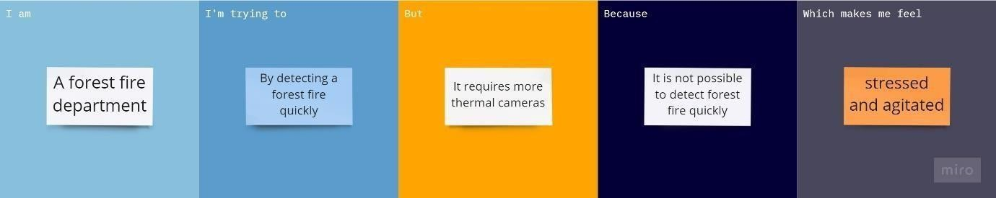

|  |  |
| --- | --- |
| **Problem statement(ps):** | Forest fires are a major environmental issue, creating economic and ecological damage while endangering human lives. There are typically about 100,000 wildfires in the United States every year. Over 9 million acres of land have been destroyed due to treacherous wildfires. It is difficult to predict and detect Forest Fire in a sparsely populated forest area and it is more difficult if the prediction is done using ground-based methods like Camera or Video-Based approach. Satellites can be an important source of data prior to and also during the Fire due to its reliability and efficiency. The various real-time forest fire detection and prediction approaches, with the goal of informing the local fire authorities. |
| **IAM** | A Forest fire department |
| **I’m trying to** | Frequently monitor fire and make sure to prevent them from getting destroyed. Analyze data from various thermal camera’s |
| **But** | Requires a lot of thermal cameras for monitoring |
| **Because** | It’s really hard to cover large boundaries and monitorthem 24 hours a day |
| **Which makes me feel** | Stressed and agitated about the forests are burning fast. |